**Loading Data into an Atlas Cluster**

MongoDB Atlas provides sample datasets that can be loaded into the cluster by executing a few simple steps. These sample databases are large, real-life datasets that are made available for practice. The sample dataset in MongoDB Atlas has the following databases, where each database has multiple collections:

* **sample_mflix**
* **sample_airbnb**
* **sample_geospatial**
* **sample_supplies**
* **sample_training**
* **sample_weatherdata**

Of all these datasets, it will be the **sample_mflix** dataset that we use. This is a database with over 21,349 movies and series records along with their ratings, comments, and other details.

The following are the steps to be executed in order to access the sample data:

1. Visit <https://cloud.mongodb.com/> and click to log in to your account:

Since you already have a cluster created on the cloud, upon login, you can find the page:

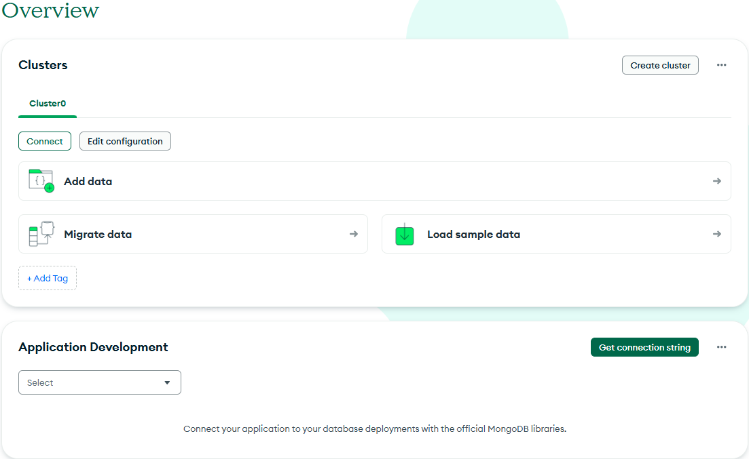

1. Click **Load Sample Dataset**. You will see a message saying **Deploying your data...** on the screen. It may take a few minutes to load the data and redeploy the cluster instances.
2. Once the dataset has successfully loaded, you will see a success message saying **Sample dataset successfully loaded**.

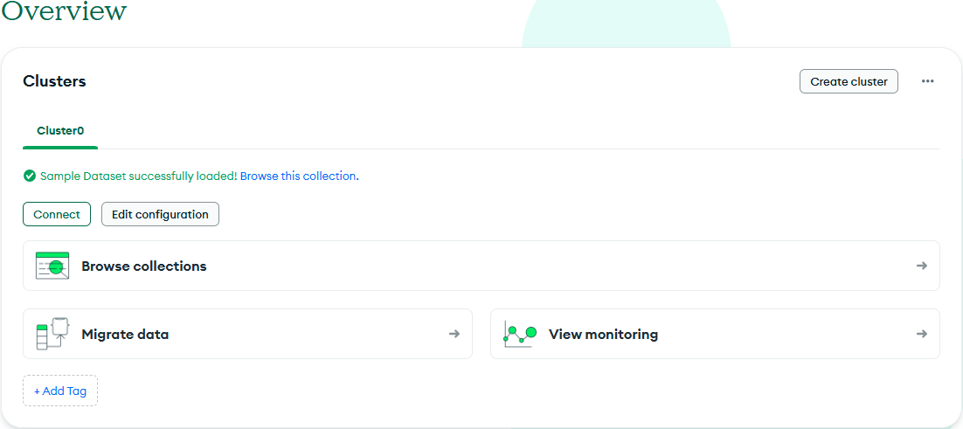

1. Now, click **Browse** **Collections**. On the next screen, you will see the following list of available databases:

Figure 2.18: List of sample databases


1. Click the down arrow next to **sample_mflix**.
2. Select the **movies** collection.

Your result for the first 20 documents will be displayed as follows:

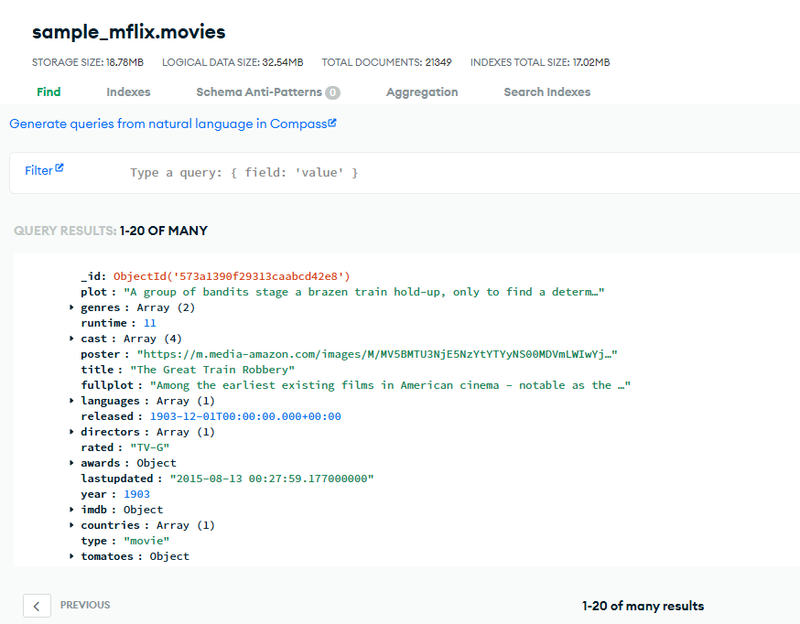

Figure: Movies collection on the cluster

We were able to load the **sample_mflix** database into our cluster.